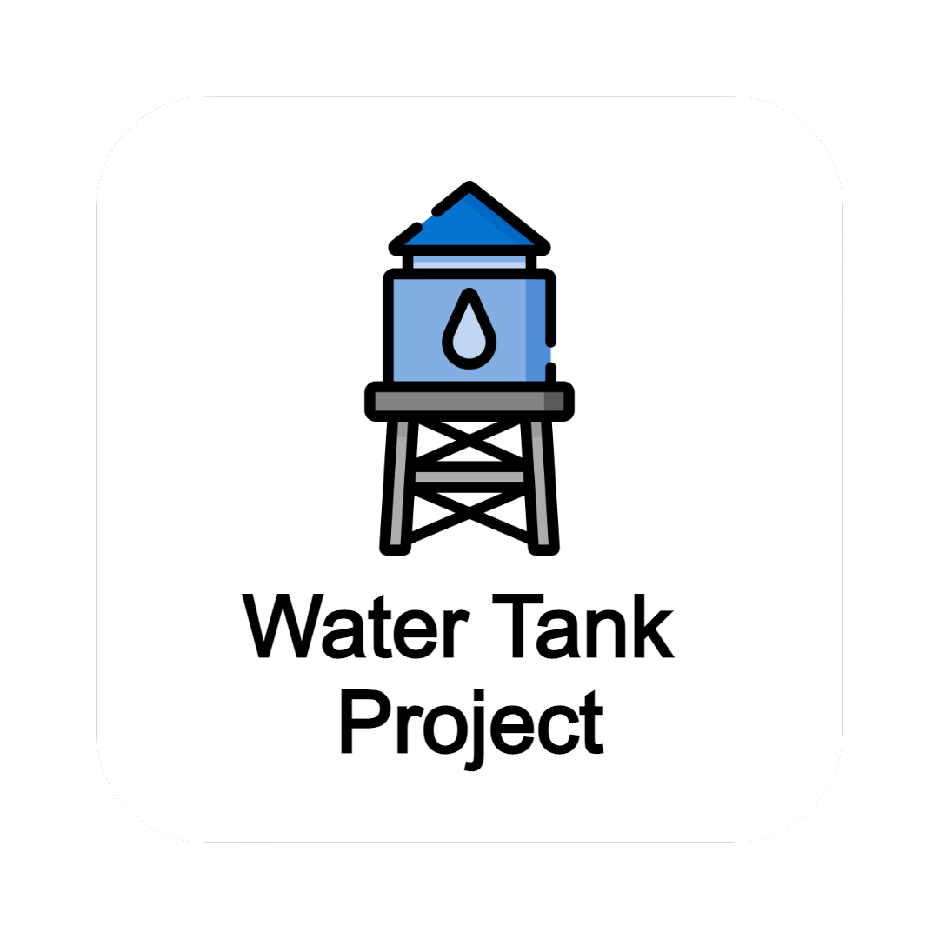

**Esp 32 Based Water Tank Project**

**March 15th**

Document Status: **Draft** | In Review | Approved

**Executive Summary:**

*The project focuses on modernizing the traditional electrical panel board of water tank by integrating advanced ESP-32 based electronic controller. The conventional panel boards have limitations in terms of efficiency, safety, and functionality. By transitioning to electronic controllers, we aim to enhance the management, monitoring, and control of water tank systems, ultimately improving user experience and resource utilization.*

|  |
| --- |
| **Project Goals** |
| * Enhance controllability **100%\*** by offering finer control over various parameters such as water levels, valve position, motor status at the end of the first month. * Reduced Size and Weight of the system by **10%\*** replacing purely electrical counterparts by electronic components. * Increase flexibility by **10%\*** in terms of functionality and adaptability by making it easy to accommodate changes in requirements or technological advancements at the end of the first month. * Advancing features enable the implementation of advanced features and functionalities such as wireless communication and real time monitoring. * Reducing the cost **10%\*** by reducing energy consumption, lowering maintenance requirements. |

**\* - Values may differ from reality due to the nature of Project.**

|  |
| --- |
| **Deliverables** |
| 1. ESP 32 based electronic automation system to replace current electrical system. 2. Real-time status monitoring android mobile application. 3. Basic training program for the staff to adopt with new technology. 4. User manual and project report documents. |

|  |
| --- |
| **Business Case / Background** |
| In today's rapidly evolving technological landscape, businesses across various industries are constantly seeking innovative solutions to enhance efficiency, streamline operations, and improve user experience. Within our organization, the management of water tank systems plays a crucial role in ensuring optimal resource utilization, operational reliability, and user satisfaction. However, the existing infrastructure relying on traditional electrical panel boards for water tank control and management presents several limitations and challenges.   * **Limited Functionality:** Conventional electrical panel boards offer basic control functionalities, limiting our ability to implement advanced features such as automated scheduling, remote monitoring, and predictive maintenance. * **Manual Intervention:** The reliance on manual intervention for monitoring and controlling water tank systems poses risks of human error, inefficiencies, and delays in addressing operational issues. * **Safety Concerns:** Outdated panel boards may lack integrated safety mechanisms, increasing the risk of electrical faults, leaks, and other hazardous incidents. * **Resource Inefficiency:** Without intelligent control algorithms, water tank systems may consume excessive energy and water, leading to unnecessary costs and environmental impact. * **Lack of Scalability:** As our organization grows and expands, the current infrastructure may not accommodate future requirements, necessitating costly upgrades or replacements. |

|  |
| --- |
| **Benefits, Costs, and Budget** |
| **Benefits:**   * Enhance controllability (More Controllable Parameters) * Lower weight and size (Reduced Size and Weight) * More Flexibility (Easy to accommodate changes) * Lower Running cost (lower energy consumption and maintenance requirements)   **Costs:**   * Hardware and Software implementation costs - Rs. 867,812.16 * Mobile application development cost - Rs. 30,000.00 * Training requirements fees - Rs. 45,000.00   **Budget needed:**   * Rs. 942,812.16 |

|  |
| --- |
| **Scope and Exclusion** |
| **In-Scope:**   * Electronic automation system * Android mobile app * Training protocols * Improve efficiency   **Out-of-Scope:**   * Improving/replacing mechanical system * Improving/replacing electro-mechanical system * Training for staff outside the working area. |

|  |
| --- |
| **Project Team** |
| **Project Sponsor:** Eng. Milan Harsha Kumara  **Project Lead:** Eng. Milan Harsha Kumara  **Project Team:** Eng. Milan Harsha Kumara  J.C.B. Kehelwattha  P.D.N.D. Silva |

|  |
| --- |
| **Measuring Success** |
| **What is acceptable:** |